A Scientist’s Search for Bigfoot by Tetsuo Fuji Ready Instruction, pages 20 – 21
Name _________________________________________________ Date ________________________ Period ___
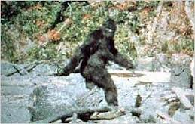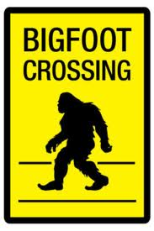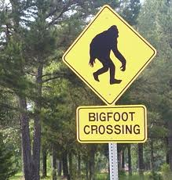

- Using context clues, define the following:
artifact | noun
hoax | noun
anatomy | noun

- The author describes Dr. Meldrum’s casts and artifacts. Most are hoaxes but others interest him. What makes Dr. Meldrum believe we should investigate Bigfoot claims?
______________________________________________________________________________________________________________________________________________________________________________________________________________________________________________________________________________________________________________________________________________________________________________________________________________________________________________________________________________________________________________________________________________________________________________________________________________________________________________________________________________________________________________
____________________________________________________________________________________________________________________________________________________________________________________________________

