Tales of Chupacabras by Cynthia Burnham Ready Instruction, pages 22 - 23
Name _________________________________________________ Date ________________________ Period ___
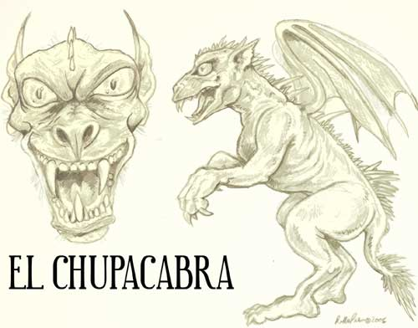
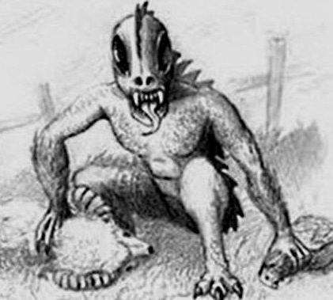
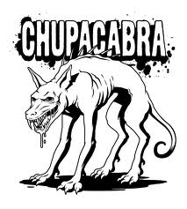

- Using context clues, define the following:
vertebrate | noun
empower | verb
lurk | verb
evade | verb

- “Morph” the words:
noun | verb | adjective | adverb
 | ---- | mythical
fatality | ----

- Watch the TV news report from Louiville, Kentucky’s WLKY News and complete the graphic organizer:
http://www.youtube.com/watch?v=YEdkoXwX0fg
On your own, you can watch two more news report showing “evidence” of the existence of the Chupacabra:
http://www.youtube.com/watch?v=I6vRdy4SO4Y
http://www.youtube.com/watch?v=dtoQGeeTUAg

Notes from the WLKY news report:
Scientific theories to explain the creature | Mark Hawthorne’s evidence to disprove the theory

- The author explains that there is enough evidence to consider the existence of the chucacabra. Why would someone believe the chupacabra is real? Include at least three details from the text in your response.

______________________________________________________________________________________________________________________________________________________________________________________________________________________________________________________________________________________________________________________________________________________________________________________________________________________________________________________________________________________________________________________________________________________________________________________________________________________________________________________________________________________________________________
____________________________________________________________________________________________________________________________________________________________________________________________________
____________________________________________________________________________________________________________________________________________________________________________________________________

