Race to Reach the South Pole: Scott vs. Amundsen Ready Instruction, page 22, AIS 7
Name __________________________________________________ Date ______________ Period ____
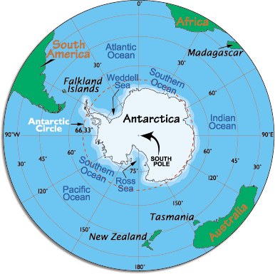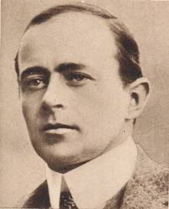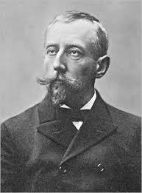
South Pole Scott Amundsen
- Using context clues, define the following:
confident | adjective
recruit | verb
veteran | adjective
unsettling | adjective
disillusioned | adjective

- Using the chart, convert the temperatures from Fahrenheit to Celsius:
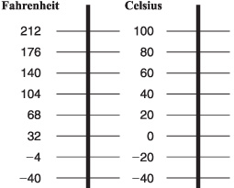
212ᵒF = _______ᵒC
68ᵒF = _______ᵒC
32ᵒF = _______ᵒC
-4ᵒF = _______ᵒC
-40ᵒF = _______ᵒC

- Record your observations about how each explorer prepared for this journey:

Scott | Amundsen

- After taking notes in your book, write a short response explaining why Amundsen succeeded. Begin with a thesis or topic sentence. Be sure to include at least three detailed sentences with textual evidence to support your thesis.

______________________________________________________________________________

______________________________________________________________________________

______________________________________________________________________________

______________________________________________________________________________

______________________________________________________________________________

_____________________________________________________________________________

______________________________________________________________________________

______________________________________________________________________________

______________________________________________________________________________

Watch 2 minute Photostory project on the race to the South Pole. http://www.youtube.com/watch?v=1ozVa4oELIA
Watch 2 minute reenactment of a challenge faced by Amundson’s team http://www.youtube.com/watch?v=p3QHIBDOcwU
Enrichment Activity for Reading Rewards:
Watch a 10 minute video on Amundson’s journey. Write at least one paragraph about it. Remember, a paragraph must including a topic sentence (in the introduction it is the thesis statement) and three detailed supporting sentences.
http://www.youtube.com/watch?v=kW5p7ANwAU4

