**APA Style Guide:**

**A Resource for Writing Research Papers**

[](http://www.google.com/imgres?q=sachem&num=10&hl=en&biw=1366&bih=622&tbm=isch&tbnid=tgaXng1jPE8RtM:&imgrefurl=http://www.sachem.edu/schools/cayuga/&docid=jqtl_7939zWiFM&imgurl=http://www.sachem.edu/schools/cayuga/sachem.gif&w=216&h=216&ei=eZcRUKTkDqSj6wH75IGwBg&zoom=1&iact=hc&vpx=397&vpy=320&dur=233&hovh=172&hovw=172&tx=95&ty=79&sig=112645766694306803266&page=1&tbnh=119&tbnw=118&start=0&ndsp=25&ved=1t:429,r:19,s:0,i:200)

**Prepared for the students at**

**Sagamore Middle School**

**Holtsville, NY**

**2012/13**

**Your name_________________________**

**Resources used in the creation of this APA Style Guide:**

APA 6e Guide: Indiana Wesleyan University

<http://www2.indwes.edu/ocls/apa/apa6eguide.pdf>

[APA Research Manual: A Guide for Keene High School Students](http://www.google.com/url?sa=t&rct=j&q=apa%20research%20manual%3A%20a%20guide%20for%20khs%20students&source=web&cd=1&ved=0CE8QFjAA&url=http%3A%2F%2Fkeene.k12.nh.us%2Fdocuments%2FAPA__Manual.pdf&ei=FCMQULedJ8OS0QHy34DQDw&usg=AFQjCNGN6yltdMLfFBBuynDpht-4z6p3Eg)

keene.k12.nh.us/documents/APA__Manual.pdf

Carmenita Middle School Style Guide

[www.carmms.abcusd.k12.ca.us/pdf/English_Dept_Style_Guide.pdf](http://www.carmms.abcusd.k12.ca.us/pdf/English_Dept_Style_Guide.pdf)

Easy Bib. Write Smart <http://www.easybib.com/>

Publication Manual of the American Psychological Association, 6e. (2010

Purdue OWL (Online Writing Lab). <http://owl.english.purdue.edu/owl/resource/560/01/>

**Writers/Editors (Summer 2012)**

Elizabeth Gennosa

Heather Stumpf

Denise Cinco

**Sagamore Middle School**

57 Division Street

Holtsville, NY 11742

To share comments or suggestions regarding this guide, email [egennosa@sachem.edu](mailto:egennosa@sachem.edu)

**APA Format – Used for Middle School Research Papers**

**Purpose**

Rules for the preparation of research papers should contribute to clear communication. These rules introduce the uniformity, or one consistent style of writing, that is required in high school and college.

**Writing Style**

The writing style in a research paper should be concise, precise, and utilitarian. Clarity is essential, and active voice is a must. Be explicit in stating information, providing relevant facts, quotes, or other details to support statements.

**This Style Guide**

A team of educators surveyed the best examples of APA style guides available online. Style guides from Carmelita Middle School, Keene High School, Indiana Wesleyan University, Purdue OWL and EasyBib were selected as models for this guide. The APA Publication Manual 6th edition was used to assure accuracy. Some of the elements of APA are modified in this manual to best meet the needs of middle school students.

For more information regarding APA, refer to the APA Publication Manual 6th edition or two excellent web resources, [EasyBib](http://www.easybib.com) and [Purdue OWL](http://owl.english.purdue.edu/owl/).

**MLA Formatting**

You will learn MLA formatting rules from your English teachers in high school. It is important to learn both styles, as certain fields of study in college strictly adhere to either MLA or APA. The differences are just a matter of style, and switching styles should not be too difficult.

**Writing Your Paper**

**Get Started**

Narrow your topic to something you can research fully. Select a topic that interests you. Develop some keywords to use to research your topic. Use reliable databases to research your topic.

**Take Notes**

As you research, always keep track of your sources of information. Write or type notes with the source information at the top, and make note of any relevant facts, quotes, or ideas found in the article.

Do not print everything you read. You don’t need this, and are better off taking notes or cutting and pasting quotes in a Word file containing source information. Always remember to record your source information when you take notes.

**Develop an Outline**

As you research and take notes, begin to develop an outline or graphic organizer. You will absolutely need this as you plan the flow of your paper. This is often done best by hand or by physically arranging your notes in the order that they would work well. Don’t just rely on the computer as a writing tool.

**Take Time to Edit**

Begin your paper early to allow for time to edit and revise. The best changes are made several days after each draft is written. Ask a friend or family member to proofread your paper before turning it in.

**Plagiarism**

Plagiarism, the act of presenting someone else’s ideas as your own, is a serious offence. It is unacceptable when submitting an original work for any class assignment or in research. You should ask yourself:

1. Have I copied, word for word, all or part of another writer’s work without giving credit to that writer and using quotation marks?
2. Have I copied the work of another writer, making changes here and there, but retaining the main thought and structure?
3. Have I included facts and supporting details from another source without giving credit?

If the answer is “Yes” to any of the above, the material is plagiarized. You need to include citations to give credit to the original authors.

**Formatting Your Paper**

**Order of the Paper**

An APA paper follows a specific format with several elements. Below is a modified format to meet the needs of middle school students:

* Title page
* Abstract (not required until the end of 8th grade in some advanced classes)
* Body of the paper
* References page

**General Paper Formatting in Word**

* See a YouTube™ video about formatting papers in Word 2007 for APA 6th ed.

(<http://tinyurl.com/APAFormat2007>)

* Use the margins function (in Word 2010 this is under Page Layout) and verify that the margins are set of one inch on all four sides. This is the default for Word 2010. For your final draft, set your paper for double spacing. This is found on the Home ribbon in the Paragraph area.

(Some teachers will ask for 1.5 spacing to save paper. This guide has 1.15 spacing.)



* Later versions of Word by default add a little extra space between paragraphs. In other words

any time you do an Enter on your keyboard, you get an extra space. To alleviate this default you need to

modify some settings each time you start a new paper. Click on the arrow for the Paragraph section on the Home ribbon.

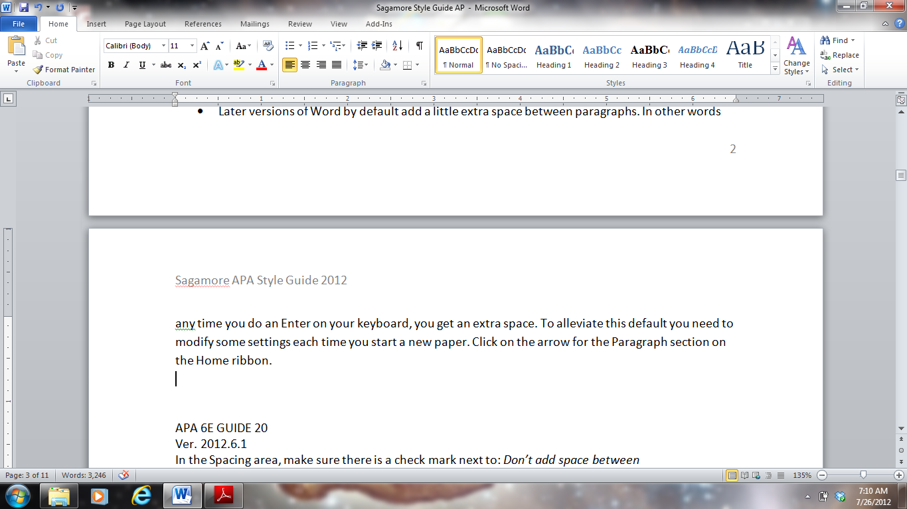 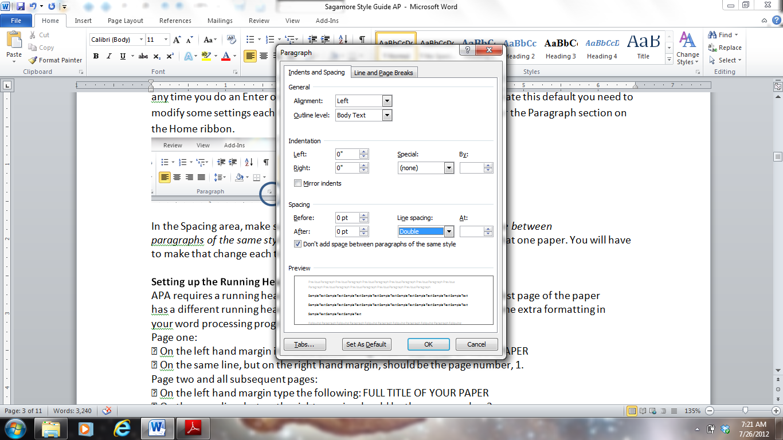

In the Spacing area, make sure there is a check mark next to: *Don’t add space between*

*paragraphs of the same style.* This will take care of that default setting for that one paper. You will have to make that changeeach time you start a new paper.

**Setting up the Running Head**

APA requires a running head on every page of the paper. (When you get to college, the Title page or first page of the paper has a different running head from the remainder of the paper. This takes extra formatting, so or middle school, you will keep the same running head throughout the paper.)

**Running head in Word 2007/2010.**

* Starting at the top of page 1, go to the Insert ribbon.
* Select Header, and select the first option (header at top left corner)
* Enter an abbreviated version of your title in all capital letters.
* Close the red Header and Footer box in the upper right corner in the task bar.
* There are modifications in this guide to simplify the running head requirements. For more details, see a YouTube™ video about formatting papers in Word 2007 for APA 6th ed.

(<http://tinyurl.com/APAFormat2007>)

**Setting up Page Numbers**

**To place the number in the lower right corner.**

* Starting with page 1, go to the Insert ribbon.
* Select Page Number, and select Bottom of Page to insert the number in the lower right hand corner. (APA formatting places the number in the upper right corner, but this requires special formatting. The lower right corner is fine, and it is much easier.)

**Removing Hyperlinks for URLs**

Web addresses used in References entry should not show a hyperlink in APA. Word processing

programs want to automatically hyperlink these, turning them blue with an underline. Hyperlinks

can be easily removed.

* Place the mouse over the hyperlink.
* Right click.
* Click on: Remove hyperlink.

**Reference List Creation for WORD 2007/2010**

A simple way to create your references is to use the ruler and drag the bottom part of the two arrows over one ½ inch. This will create the hanging part of the References entry. When you type the lines, Word will wrap and any second or subsequent line to the hanging indent marker. When hit “Enter” to start a new entry, the cursor will return to the left hand margin. Your typing should look like

the example in the illustration below. If you have already typed your sources, simply highlight the References and move the bottom arrow over one ½ inch.

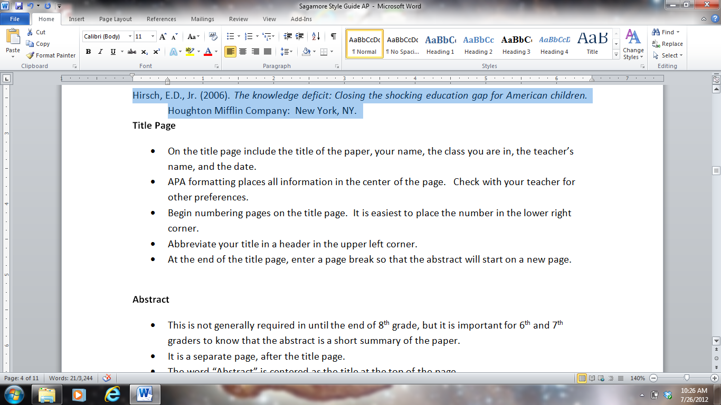

Hirsch, E.D., Jr. (2006). *The knowledge deficit: Closing the shocking education gap for American children.* Houghton Mifflin Company: New York, NY.

**The Content and Organization of the Paper**

**Title Page**

* On the title page include the title of the paper, your name, the class you are in, the teacher’s name, and the date.
* APA formatting places all information in the center of the page. Check with your teacher for other preferences.
* Abbreviate your title in a header in the upper left corner (see p. 5).
* Begin numbering pages on the title page. (see p. 7).
* At the end of the title page, enter a page break so that the abstract or the body of the paper will start on a new page.

**Abstract**

* This is not generally required until the end of 8th grade in some advanced classes, but it is important for 6th and 7th graders to know that the abstract is a short summary of the paper.
* It is a separate page, after the title page.
* The word “Abstract” is centered as the title at the top of the page.
* Do not indent the abstract paragraph.
* Summarize your paper in 150 – 250 words. Include your thesis statement in the abstract and summarize main points made in the paper.
* At the end of the abstract, enter a page break so that the body of the paper will start on a new page.

**Body of the Paper**

The body of the paper is generally three to five pages long in middle school. Begin by introducing your topic and state your thesis. This is a statement about your topic that you will support with evidence from multiple sources. Your purpose is to persuade or inform your readers about one aspect of your topic.

The following paragraphs will support your thesis. They will include quotes, paraphrasing, facts, and ideas from other authors. All of these items will need parenthetical citations, and later will need to be included in the References page. A parenthetical citation tells the reader the author’s name and the year when the source was published. The reader then can find this reference on the References page and get more information, allowing the reader to find the source to verify/ gain new information.

Finally, the paper needs a conclusion to restate your thesis in a way that includes a summary of your main points made in the paper. When finished with the body of the paper, enter a page break so that the References page will start on a new page.

**General formatting rules for the body of the paper.**

* On the first page of the body, repeat the full title, centered, one inch from the top, in a combination of upper/lower case letters.
* Double space everything in a final draft. (To save paper, your teacher may ask for 1.5 spacing.)
* The preferred font is size 12 Times New Roman. Other professional looking fonts may be used. Do not use a casual or decorative font.
* Margins are set at 1-inch on all four sides (default setting).
* Do not justify the right margin; justify only the left margin.
* Do not break words at the end of a typed line (hyphenation).
* When using quotations, ending punctuation belongs inside the quotation marks. Other punctuation (a question mark) is outside the quotation marks unless part of the quotation.
* Indent paragraphs 5 to 7 spaces.
* Include parenthetical citations to cite all of the sources you are using to support your thesis. To format parenthetical citations, see pages 8 - 10.
* Avoid lengthy paragraphs. They should not be longer than 2/3 of the page.
* Avoid biased or pejorative language. Remain objective and fair.
* Use two spaces after all end punctuation. However, do not space after internal periods in abbreviations such as U.S.

**Abbreviations.**

* Use abbreviations sparingly; APA style prefers no abbreviations unless they are acronyms.
* If using acronyms, spell out the abbreviation in full the first time it is used.
* To make plurals out of acronyms, add “s” only. Ex: many CDs

**Numbering.**

* Use numerals with numbers 10 and above. Spell out numbers nine and below.
* Spell out a number if it begins the sentence.
* To make plurals out of numbers, add “s” only. Ex: early 1800s

**Formatting for headings.**

* Use headings to organize your paper and to guide the reader. This should follow your outline or graphic organizer.
* Do not label headings with numbers or letters.
* Use at least two levels of headings. This guide uses three levels of headings. College-level papers will use five levels.
* Follow the correct formatting for headings:

**Level One Heading: Centered, Boldface, Uppercase and Lower Case**

Start paragraph with a normal paragraph indent.

**Level Two Heading: Flush Left, Boldface, Uppercase and Lower Case**

Start paragraph with a normal paragraph indent.

**Level three heading.: Indented, boldface, lowercase, ending with a period.** Start sentence after the period.

**Citations.**

* When you include quotations, facts, or paraphrased statements from another author, you need to cite the source. A parenthetical citation gives credit to the original author, allowing your reader to find this source him/herself.
* It does not matter whether you quote directly or reword a concept into your own wording; both examples require an in-text citation.
* Items that do not need to be cited include your own ideas, your personal experiences, and common knowledge.
* Citations appear at the end of a quote or paraphrased statement and include the author’s last name, a comma, and the year the source was published, in parentheses, with the ending period outside (Gennosa, 2012).
* If there is no author available, shorten the title and include the year published (*APA Guide*, 2012)
* Short quotations of fewer than 40 words should be incorporated into the text and enclosed by quotation marks.
* Long quotations of 40 or more words do not use quotation marks. Do not single space them. Indent 5 to 7 spaces from the left margin for the entire quotation. If longer than one paragraph, indent the first line of each additional paragraph 5 to 7 spaces more.
* Type ellipsis points (used to indicate omissions within a sentence) by using three periods with spaces before and after the periods. If indicating omissions between two sentences, use four periods.

**Examples of including a citation.**

* If the author is mentioned within the paragraph, just include the year in parenthesis after the author’s last name:

Daniels and Zemelman (2004) recommend that readers should read a wide range of genres.

* To include a direct quote, include the page numbers at the end:

Teachers should include music, art, movie clips, and the internet to “invite adolescents into the text and to help them consider important issues and questions” (Wold & Elish-Piper, 2009, p.88).

Daniels and Zemelman (2004) state that “students do need to know, consciously, that smart readers use a variety of different cognitive lenses to spot the meaning in tough texts” (p. 32).

**In-text and parenthetical citation formatting quick guide.**

* One author:
  + Jones (2010) notes . . .
  + (Jones, 2010).
* Two authors:
  + Smith and Jones, (2009) acknowledge . . .
  + (Smith & Jones, 2009)
* Three to five authors
  + Smith, Jones, and Brown (2011) maintain . . . The next time that source is used it would be Smith et al. (2011) agree that . . .
  + (Smith, Jones, & Brown, 2011), for the first time the source is cited. Thereafter, for that source, use (Smith et al., 2011).
* Six or more authors
  + Smith et al. (2012) propose . . . (The first time the source is used, just note the first author with et al.)
* No author
  + Use the first few words of the title, since the title has now moved to the first position in the References entry.
  + For short works use quotation marks: (“Fun Learning APA,” 2010).
  + For books and major works, italicize: (*The Publication Manual*, 2009).
* Author is quoted in another text
  + Occasionally you will use a quote that someone else has quoted in an article/book that you are reading. This needs to be documented as a secondary source.

Franklin stated, “A penny saved is a penny earned” (as cited in Burchell, 2000, p. 45).

* + The References entry would be for the book by Burchell. Franklin is not cited in the References list: Burchell, B. (2000). *The life of Ben Franklin.* Philadelphia: Freedom Press.

**Transitioning quotes into your paragraph.**

Signal words are good introductions for text that you are quoting or paraphrasing. In the examples shown, the signal words “state” and “recommend” are used. Here are some other suggested signal words:

|  |  |  |  |
| --- | --- | --- | --- |
| acknowledge | believe that | emphasize | propose |
| add | claim | explain | report |
| admit | reveal | agree | conclude |
| argue | observe | speculate | ask |
| suggest | assert | describe | write |

**References Page**

* Start the reference list on a new page. Inserting a page break at the end of the body of your paper will always keep your References at the top of a new page.
* Type the word “References” in upper and lowercase letters, centered at the top of the page.
* Any source listed on the References page must be cited in the body of the paper.
* List references in alphabetical order.
* Double-space all entries.
* Beginning entries should not be indented. Second or subsequent lines are indented.
* Only one space is needed after periods in a reference entry.
* To format the references page, see page 5 of this guide.

**Examples of formatting of references.**

* **Book with One Author:**

Author’s last name, First initial. (Year of Publication). *Title of book in italics with only first word capitalized unless a proper noun or first word following a colon.* City where published, Postal code abbreviation of state: Publishing company.

Vygotsky, L. S. (1962). *Thought and language*. Cambridge, MA: MIT Press.

Gallas, K. (1994). *The languages of learning: How children talk, write, dance, draw, and sing their understanding of the world*. New York, NY: Teachers College Press.

* **More than one author, use “&”:**

Freire, P. & Macedo, D. (1987*). Literacy: Reading the word and the world.* Hadley, MA: Bergin & Garvey.

Wegener, D. T., & Petty, R. E. (1994). Mood management across affective states: The hedonic contingency hypothesis. *Journal of Personality and Social Psychology, 66*, 1034-1048.

* **Book with an editor, use “(Ed.)” or “(Eds.)”:**

Snow, C. E., Burns, M. S. & Griffin, P. (Eds.). (1998*) Preventing reading difficulties in young children.* Washington, DC: National Academy Press.

* **Edited book with an author:**

Plath, S. (2000). *The unabridged journals.* K. V. Kukil (Ed.). New York, NY: Anchor.

* **Article in a periodical (magazine, newspaper, etc.):**

Author, A. A., Author, B. B., & Author, C. C. (Year). Title of article. *Title of Periodical, volume number*(issue number), pages. For a newspaper, include the date of issue.

Harlow, H. F. (1983). Fundamentals for preparing psychology journal articles. *Journal of Comparative and Physiological Psychology, 55(5)*, 893-896.

Schultz, S. (2005, December 28). Calls made to strengthen state energy policies. *The Country Today*, pp. 1A, 2A.

* **Electronic Resources:**

Author, A. A., & Author, B. B. (Date of publication). Title of article. *Title of Online Periodical, volume number*(issue number if available). Retrieved from   
http://www.someaddress.com/full/url/

Bernstein, M. (2002). 10 tips on writing the living Web. *A list apart: For people who make websites, 149*. Retrieved from http://www.alistapart.com/articles/writeliving

* For more examples of resource entries, visit [Purdue OWL](http://owl.english.purdue.edu/owl/section/2/10/) or [EasyBib](http://content.easybib.com/students/citation-guide/apa/).