“Are Our Nation’s Treasures in Danger?” and “Underused Parks Work to Create Awareness, Access” –
Building Background Knowledge and Vocabulary to Meet the Text with Success!

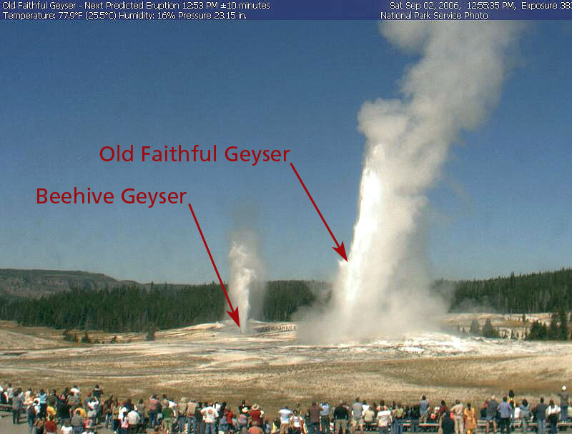

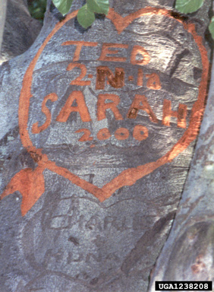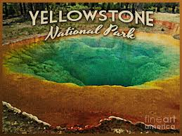

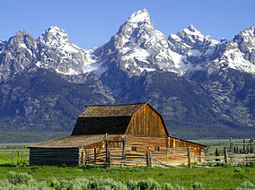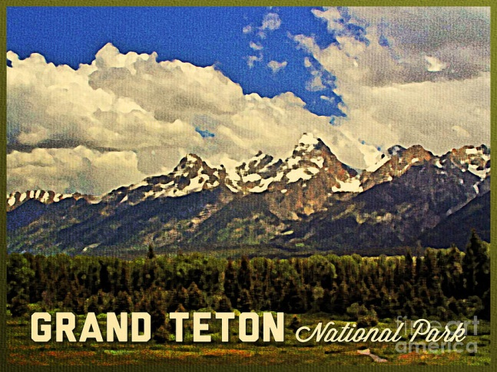
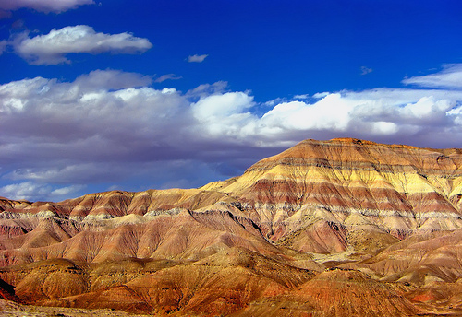
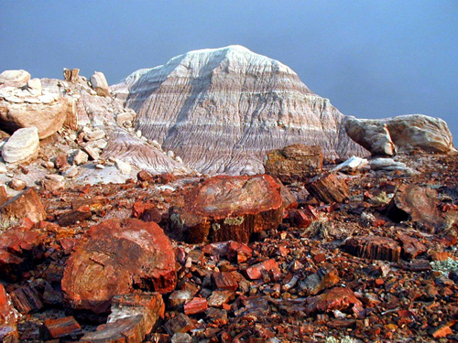
Petrified Forest National Park
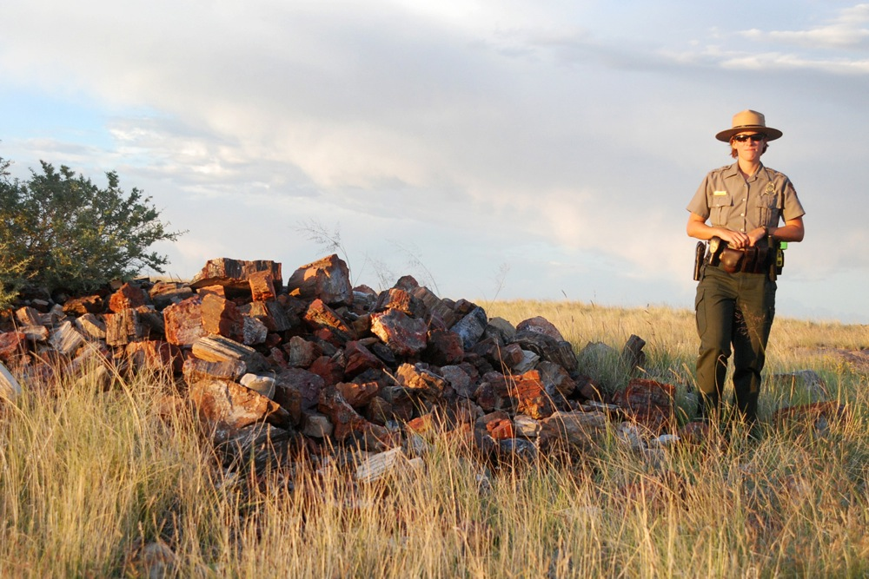

Painted Desert in Arizona

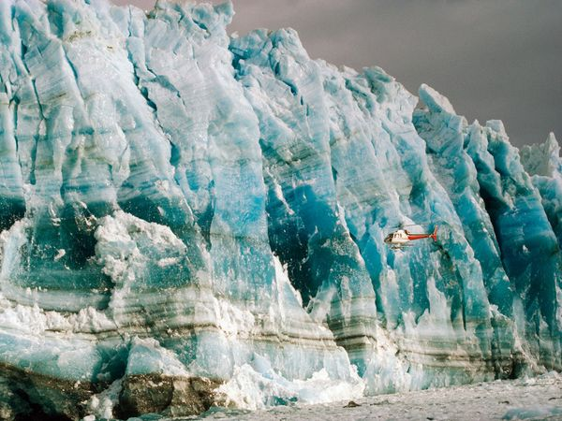
Wrangell – St. Elias National Park in Alaska

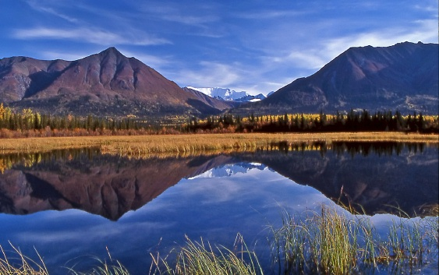

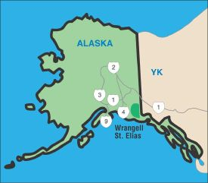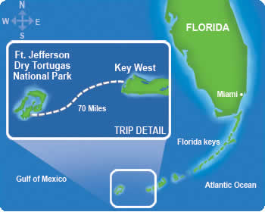
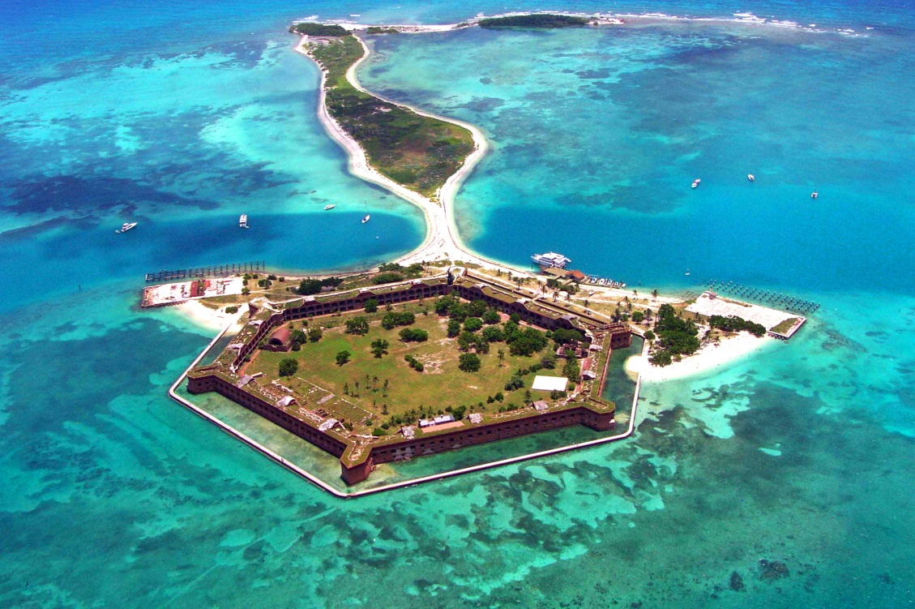
Dry Tortugas National Park
Words to Know –
Lodging – places to stay (hotels, motels)
Thievery – stealing, theft
Discard – to throw away
Throng – swarm, (throng to – go to in a large group)
Utmost – highest
Inhibit – to prevent, restrain
Optimism – hopefulness and confidence about the future
Serenity – peacefulness
Remnant – something left behind

