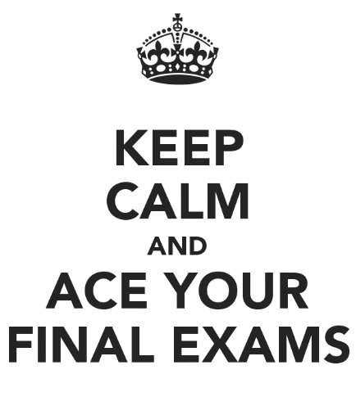
English 7R/7H Final Exam Review Guide
The English final exam is in three parts:
- It begins with two or three engaging readings with questions that require you to read carefully.
- You will then answer questions about some of the literature you read this year.
- The exam will end with questions on word parts, vocabulary and grammar.
Be prepared to:
- Read carefully! Go back to the text and use the numbered paragraphs to find the right section to read again. This is very important!
- Infer from the text. Draw conclusions about what you are reading. The answers are not always “right there.” You need to gather details and come up with a conclusion based on the text.
- Understand details and select the “best answer” given. Some are “all of the above,” so read each choice carefully!
- Identify the mood or tone of a text. Find details that add to the mood or tone.
- Determine the meaning of several words through context. (Notice that underlined words are important.) Try to understand their meaning through context as you read.
- Find details to support a statement.
- Determine the theme or main idea of a text.
- Understand the structure of a text: main idea/details, cause/effect, the development of an idea.
Some extra vocabulary to know:
- anticipation - _____________________________________________________________
- excerpt and selection - _____________________________________________________
- conclude - _______________________________________________________________
- context - ________________________________________________________________
- emphasize - ______________________________________________________________
- compassionate - __________________________________________________________
- considerate - _____________________________________________________________
- “in vain” - _______________________________________________________________
- prejudice - _______________________________________________________________
- villain - _________________________________________________________________
Genres:
- Historical fiction - _________________________________________________________
- Science fiction - ___________________________________________________________
- Realistic fiction - __________________________________________________________
- Fantasy - ________________________________________________________________
- Myth, legend, folktale - ____________________________________________________
- Teleplay, play, drama - _____________________________________________________
- Non-fiction article - ________________________________________________________
- Biography, Autobiography, Memoir - _________________________________________
Grammar to understand:
- Using commas in lists, with different sentence types, to set off phrases
- Using apostrophes for contractions and possession
- Sentence structure and comma use
- Simple sentence
- Compound sentence
- Complex sentence
- Compound-complex sentence
Word parts to know:
- anti – ___________________________________________________________________
- ante – __________________________________________________________________
- - inter __________________________________________________________________
- -cred- __________________________________________________________________
- opus, oper – _____________________________________________________________
- clud, clus – ______________________________________________________________
- -tude __________________________________________________________________
- dis – ___________________________________________________________________
- -ive ____________________________________________________________________
- uni- ____________________________________________________________________
- claim, clam ______________________________________________________________
- -ish ____________________________________________________________________
Literary Terms:
- setting - _________________________________________________________________
- theme - _________________________________________________________________
- characteristics - __________________________________________________________
- character transformation or dynamic character - ________________________________
- plot detail - ______________________________________________________________
- author’s purpose - ________________________________________________________
- poetic literary device / poetic technique - _____________________________________
- simile - _________________________________________________________________
- metaphor - ______________________________________________________________
- personification - __________________________________________________________
- flashback - _______________________________________________________________
- foreshadowing - __________________________________________________________
- suspense - _______________________________________________________________
- climax - _________________________________________________________________
- hyperbole - ______________________________________________________________
- irony or ironic - ___________________________________________________________
- imagery - ________________________________________________________________
- symbolism - ______________________________________________________________
- end rhyme - _____________________________________________________________
- internal conflict - _________________________________________________________
- external conflict - _________________________________________________________
- narrative point of view - ____________________________________________________
- first person narration - _____________________________________________________
- second person narration - __________________________________________________
- third person limited - ______________________________________________________
- third person omniscient - ___________________________________________________
- “speaker” in a poem - ______________________________________________________

Literature Packets to Review (not all of these are on the exam) –
- The Watsons Go to Birmingham – 1963 by Christopher Paul Curtis
- The Cay by Theodore Taylor
- “Thank You, M’am” by Langston Hughes (including Dickinson poem)
- “A Retrieved Reformation” by O. Henry
- “After Twenty Years” by O. Henry
- “Dark They Were and Golden Eyed” by Ray Bradbury
- “The Monsters Are Due on Maple Street” by Rod Serling
- Poetry of Langston Hughes
- Poetry of Robert Frost
- Know your authors! Review what you learned about them.

