Guardian on the Plateau - Building Background Knowledge and Vocabulary to Meet the Text with Success!
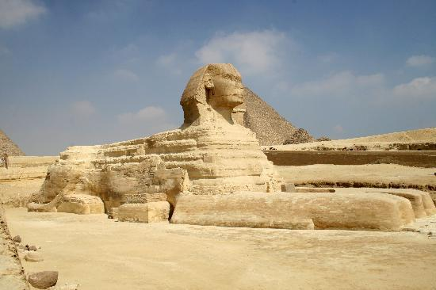
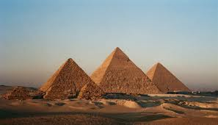

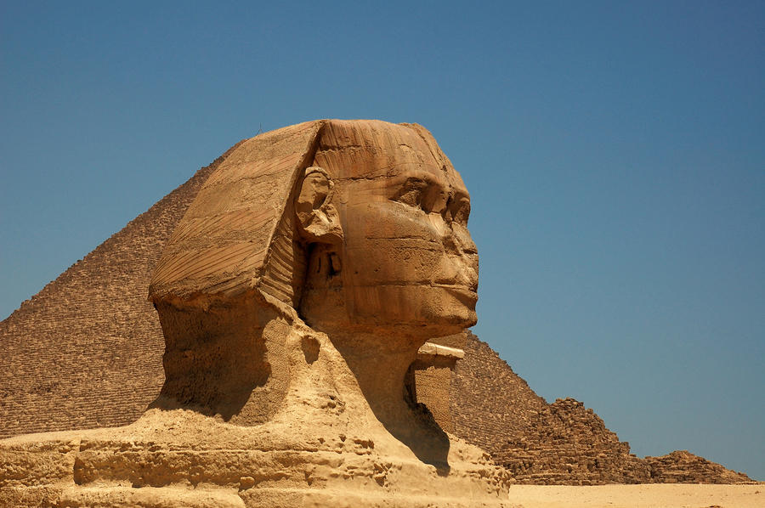
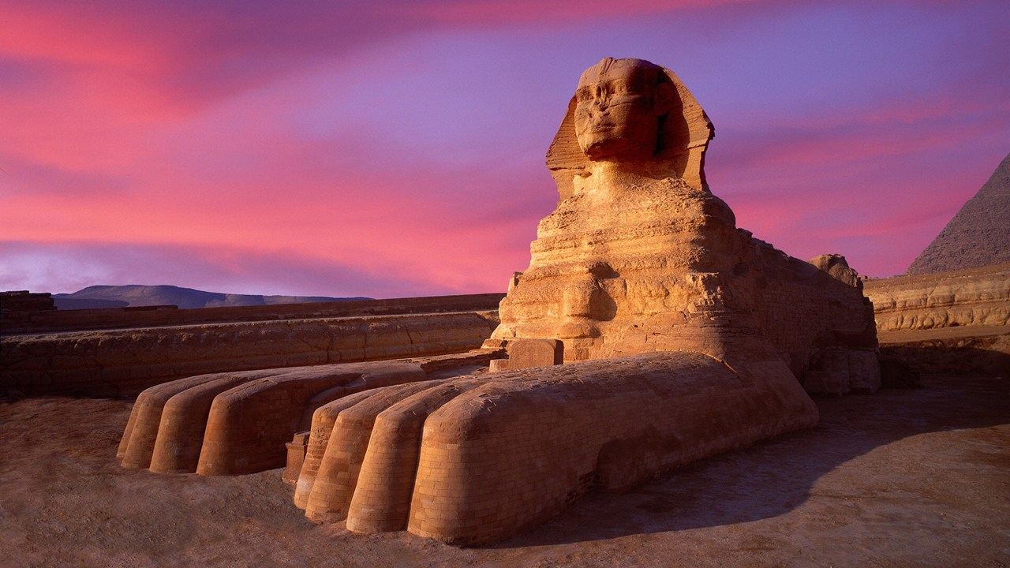
Words to Know:
Monument – memorial, structure, a lasting evidence, reminder, or example of someone or something notable
Plateau - An area of fairly level high ground.
Artisan - A worker in a skilled trade, esp. one that involves making things by hand
Quarry - A place, typically a large, deep pit, from which stone or other materials are or have been extracted.

