Name: __________________________________________________ AIS Period: _______
In 7th Grade English, all students study selected stories by O. Henry. In this unit, you will explore one story, “The Ransom of Red Chief” by O. Henry and will learn about others.
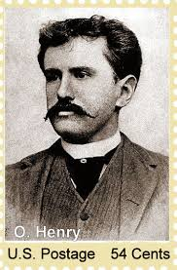
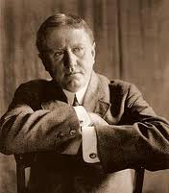
To begin, let’s learn/review some interesting facts about the author with an Author Webquest.

It’s important to know about our most famous American authors. They are our heritage!

DIRECTIONS: Use the websites to explore information about the author of our next story. The links are posted on our class website, www.elahelp.com on the AIS page.

http://www.biography.com/people/william-sydney-porter-9542046

http://www.online-literature.com/o_henry/ http://www.imdb.com/name/nm0377958/bio

1. What is O. Henry’s REAL name? ___________________________________________________
2. Who raised him? Why? _____________________________________________________________________________
_____________________________________________________________________________3. Why did O. Henry to flee to Honduras? ____________________________________________
_____________________________________________________________________________
4. What brought him back to America? _____________________________________________________________________________
5. What did O. Henry do while in prison? ________________________________________________________________________
6. How long was he in prison? ____________________
7. Why did he change his name to “O. Henry”? How did he come up with the name?
__________________________________________________________________________________________________________________________________________________________
8. Where did he live for most of his life after prison? __________________________________________________________________________
- What is typical of O. Henry’s stories? What did he write about? (Three details)

______________________________________________________________________________________________________________________________________________________________________________________________________________________________________________________________________________________________________________________________________________________________________________________________________________________________________________________________________________
- We will discuss three O’Henry stories. Throughout this unit, we will complete the graphic organizer to compare the stories, and discuss the similarities. We will focus on the character types and the use of irony (a strange twist or coincidence) usually found at the end of a story.

Title | “A Retrieved Reformation” | “After Twenty Years” | “Ransom of Red Chief”
Character types
Ironic ending

