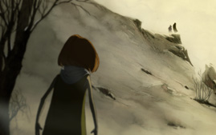
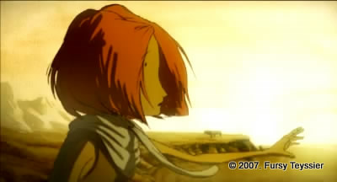

Name ____________________________________________ Date __________ period ___
Tir Nan Og - animated short film directed by Fursy Teyssier
This film uses no words to tell a story. Tell the story in your own words. Include the following details:
- How is death personified in this film?
- What do the crows represent?
- Where is the grandmother going? How does she react?
- How does the little child change in her perception?

____________________________________________________________________________________________________________________________________________________________________________________________________________________________________________________________________________________________________________________________________________________________________________________________________________________________________________________________________________________________________________________________________________________________________________________________________________________________________________________________________________________________________________________________________________________________________________________________________________________________________________________________________________________________________________________________________________________________________________________________________________________________________________________________________________________________________________________________________________________________________________________________________________________________________________________________________________________________________________________________________________________________________________________________________________________________________________________________________________________________________________________________________________________________________________________________________________________________________________________________________________________________________________________________________________________________________________________________________________________________________________________________________________________________________________________________________________________________________________________________________________________________________________________________________________________________________________________________________________________________________________________________________________________________________________

These are a few of the most recent posts about the short film Tir Nan Og

from people around the world sharing insight and joining a community of fans:
Jason Moore 1 week ago I'm from Ireland and we have a﻿ mythologic tale about an island called tir na nÓg were people lived forever, tir na nÓg translates to 'land of youth' maybe this short film is a mixture of both :)
Luke Davies 1 week ago tir nan og﻿ is welsh for 'crow'
crazylol2000 2 weeks ago The man is death, and at first he seemed cruel and harsh. But﻿ in the end, she saw that he was beautiful and had no regrets letting her grandmother go.
Sophie Tatarcheva-Andreoli 2 weeks ago At first she fought death, but then she embraced it.﻿
Alycia Devaney 2 weeks ago This made me﻿ nearly cry and feel emotion but what can you do if it's well just a part of life

If you could add a comment (and you can with your parents’ permission) what would you say about this film?
___________________________________________________________________________________________________________________________________________________________________________________________________

