Name _________________________________________ Date ____________________ Period _____
“RAFT” - Creative Writing with Textual Evidence for The Cay by Theodore Taylor
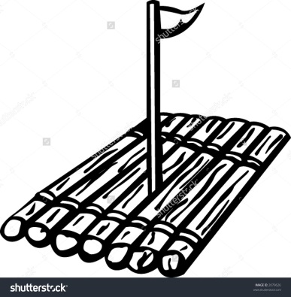
Role – You are Phillip, several months after returning to Curacao.
Audience – You are speaking to a mixed crowd at a memorial service for Timothy.
Format – You are delivering a eulogy, which is a speech or a piece of writing praising a person who has passed.
Topic – You are honoring the life and sacrifices of Timothy, focusing on all that he taught you on the island.
Be creative with your speech. If you’d like to begin or end with a short poem about Timothy, or a famous quote about something related to Timothy, that would make your eulogy stand out.

Work with your group to find at least two things that Timothy taught Phillip. Include at examples of how Timothy changed Phillip’s perspective on life, diversity, or his own abilities.
Describe two things that Timothy taught Phillip, and explain how Phillip changed because of this.
Include a quote from the novel to support what your statements.

Copy down what Timothy says about people who are a different skin color:
_________________________________________________________________________________________________________________________________________________________________________________________________________________________________________________________________________________

Some other quotes to choose from:
Where are we? Where is my mother?
I true believe you mut-thur is safe an soun’ on a raff like dis.
What do we have to do?
Stay alive young bahss, that is what we have to do.
"Do not be dishearten, young bahss. Today, we will be foun', to be true"
“ D'han' is not blin.'”
The rope, I thought. It wasn't for him. It was for me.

I remember that at one point my fear turned to anger. Anger at Timothy for not letting me stay in the water with my mother, and anger at her because I was on the raft. I began hitting him and I remember him saying, "If dat will make you bettah, go 'ead."
"you see, phill-eep, you do not need d'eye now. You 'ave done widout d'eye what I couldn't do wid my whole body."

Something happened to me that day on the cay. I'm not quite sure what it was even now, but I had begun to change.
I said to Timothy, "I want to be your friend."
He said softly, "Young bahss, you'ave always been my friend."
I said, "Can you call me Phillip instead of young boss?"
"Phill-eep," he said warmly.

'In case d'tempis' reach dis high, lock your arms ovah d'rope an' ang on, Phill-eep."
'Dis be a western starm, I b'guessin'. Dey outrageous strong when dey come,' Timothy explained

Name __________________________ Date ________________ Period ___

A Eulogy in Honor of Timothy of The Cay by Theodore Taylor
By Phillip Enright

______________________________________________________________________________________________________________________________________________________________________________________
______________________________________________________________________________________________________________________________________________________________________________________
______________________________________________________________________________________________________________________________________________________________________________________
______________________________________________________________________________________________________________________________________________________________________________________
______________________________________________________________________________________________________________________________________________________________________________________
______________________________________________________________________________________________________________________________________________________________________________________
______________________________________________________________________________________________________________________________________________________________________________________
______________________________________________________________________________________________________________________________________________________________________________________
______________________________________________________________________________________________________________________________________________________________________________________
______________________________________________________________________________________________________________________________________________________________________________________
___________________________________________________________________________________________________________________________________________________________________________________________________________________________________________________________________________________________________________________________________________________________________________
______________________________________________________________________________________________________________________________________________________________________________________
______________________________________________________________________________________________________________________________________________________________________________________
______________________________________________________________________________________________________________________________________________________________________________________
______________________________________________________________________________________________________________________________________________________________________________________
______________________________________________________________________________________________________________________________________________________________________________________
______________________________________________________________________________________________________________________________________________________________________________________
______________________________________________________________________________________________________________________________________________________________________________________
______________________________________________________________________________________________________________________________________________________________________________________
______________________________________________________________________________________________________________________________________________________________________________________
_____________________________________________________________________________________________________________________________________________________________________________________

