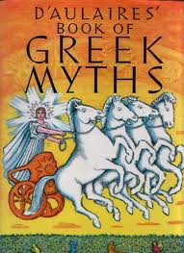
The Myths and Legends Project
The final project for the second quarter will be the “Myths and Legends Project.” You will complete other writing pieces this quarter, but throughout this time we will be reading many myths, legends, and other stories.
Research
- Select a myth, legend or folktale to explore. You may select any that we read in class. If you are selecting a new story, please print or photocopy a good version of it.
- Write a brief summary of the story. End the summary by explaining what this story tells about the people who created it. This summary will be graded and edited. It is an important part of the project. You will write this on your own but can work in a group in the next part of the project.
Respond to the Literature in a Creative Way
- If you’d like, select a group of 2 – 3 people to work with to create your project. You may also choose to work on your own. You will have at least three days to work on the project in class, but many of you will want to work on it outside of class.
- Your project is to retell or represent all or part of your favorite story. You may create a “movie” with words, music, and images using PhotoStory, create a page of a newspaper portraying events in the story, produce original artwork depicting the story, write a poem, write an original version of story, write a script and create a short film (must be done outside of class), or create anything else that shows a deep understanding of the story. You can update the story, put it in a new setting, add new characters from today’s culture, or otherwise give it a twist!
- Please drop your project in the drop folder of EGENNOSA on Sagamore’s Drop/Share files. Some of you may be asked to present your project to the class. I would like to publish some of your work on the class website and Sagamore’s Authors and Artists site, and will ask for your permission first.
Here is a great site to find a myth, legend, or folktale: http://www.americanfolklore.net/
For Greek Mythology: http://www.ilearngreek.com/mythology/greek_mythology.asp
Read along as you listen to a myth: http://storynory.com/?s=myths
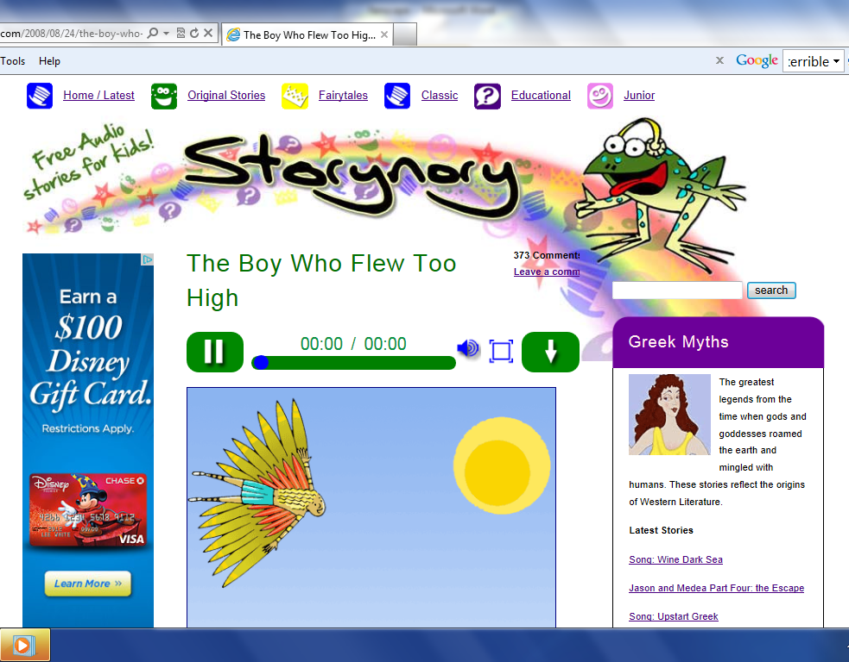
The Boy Who Flew Too High (Icarus and Daedalus)
I’ve told you before about the half man-half bull called the Minotaur. This strange and terrible beast lived in a deep, dark Labyrinth on the island of Crete. Well you may remember that the Labyrinth was created by the cunning and ingenious mind of Daedalus.
Daedalus was a brilliant architect and inventor – in fact, he was so brilliant that King Minos of Crete did not want to let him go back to his home in Athens. Instead, he kept him as a prisoner. Daedalus lived with his son Icarus in a tower of the palace, and King Minos made him invent weapons of war that would make his army and navy even more powerful than they already were.
Although Daedalus and Icarus had every comfort that they could ask for, the father longed to return home to Athens. His son hardly remembered his home city, but he too wanted to leave, because he longed to run and play in the open, rather than be in a tower all day.
Daedalus looked out over the waves of the Mediterranean Sea, and he realised that even if they could manage to slip out of the tower and find a little boat, they wouldn’t be able to sail very far before they were spotted and caught by one of the ships of King Minos’s navy.
He thought for a long time about the best way to escape, and finally he came up with a plan, and this is what he did. He told King Minos that he needed feathers and wax for a new invention that he was working on. When these were brought to him, he took them up onto the roof of the tower. Here he arranged them in four lines, starting with the smallest fathers, and following those with the longer ones, so that they formed gentle curves. Then he began to stick the feathers together with thread in the middle and wax at the base. While he was working, Icarus played with the wax, squashing it between his finger and thumb, and when the feathers blew away in the breeze he ran after them and caught them.
When Daedalus had finished, he showed Icarus his work. He had made the feathers into two pairs of wings. He fastened the larger pair to his arms, and began to flap them until his feet took off from the floor and he began to hover in mid air. Icarus laughed with delight and could not wait to try out the smaller pair of wings. Over the next few days father and son both practised with them until little Icaraus was almost as good at flying as his father.
Then one morning Deadalus said to Icarus:
“Now Son, we are ready to leave this island for good. We shall fly home to Athens. But although you are now quite good at flying, you must not forget that it can be very dangerous. So listen to my instructions and be sure to follow them to the letter. At all times follow me, for I will find the way home. Do not veer off on a different flight path, or you will soon be lost. And do not fly too low, or your wings will fill with moisture from the waves and they will become too heavy you will sink down. Nor should you fly too high, or the sun will heat the wax and your wings will fall apart. Have you understood all that I have said?”
Little Icarus nodded to show his father that he had understood. And then Daedalus led his son up onto the battlements of the tower, and like a bird leading her fledglings from the nest for the first time, he jumped into mid air and flapped his wings, and Icarus followed soon after.
If a fisherman or a shepherd had looked up just then, he would have seen two very unusual birds hovering above the waves. No doubt he would have thought that they had caught sight of two winged gods : For who could have believed that a mortal father and son had mastered the art of flight?
Over the seas they sailed, and at first Icarus felt frightened for he had never ventured very far in his practice flights. But soon he found that he was really good at flying. In fact, it was the most tremendous fun you could ever have. He began to swoop up and down with the sea gulls. Wow! It was amazing ! His father turned round and called:
“Icraus, Take Care!” and for a while after that Icraus obeyed his father and flapped along behind him. But then his wings caught a warm air current, and he found that he could soar along and upwards almost without any effort. This was the life ! He was floating ever so high above the waves and the ships down below were like tiny little specks. His father called up to him
“Icarus, remember what I told you. Come down right now!” But Icarus could not hear, and his father could not catch up with him.
Icarus was way too close to the sun, and soon the wax that held the feathers together began to melt. Gradually his wings began to lose their shape, and some of the feathers even began to fall off. Icarus flapped his arms frantically, but it was too late. He had lost the power of flight and down he plunged into the sea.

Landscape with the Fall of Icarus (1962) — William Carlos Williams
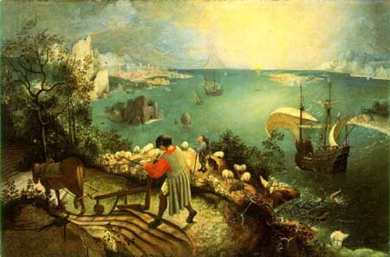
According to Brueghel
when Icarus fell
it was spring
a farmer was ploughing
his field
the whole pageantry
of the year was
awake tingling
near
the edge of the sea
concerned
with itself
sweating in the sun
that melted
the wings’ wax
unsignificantly
off the coast
there was
a splash quite unnoticed
this was
Icarus drowning

Pieter Brueghel, The Fall of Icarus
Oil-tempera, 29 inches x 44 inches. Museum of Fine Arts, Brussels.
Musée des Beaux Arts (1940)
About suffering they were never wrong,
The Old Masters: how well they understood
Its human position: how it takes place
While someone else is eating or opening a window or just walking dully along;
How, when the aged are reverently, passionately waiting
For the miraculous birth, there always must be
Children who did not specially want it to happen, skating
On a pond at the edge of the wood:
They never forgot
That even the dreadful martyrdom must run its course
Anyhow in a corner, some untidy spot
Where the dogs go on with their doggy life and the torturer’s horse
Scratches its innocent behind on a tree.
In Brueghel’s Icarus, for instance: how everything turns away
Quite leisurely from the disaster; the ploughman may
Have heard the splash, the forsaken cry,
But for him it was not an important failure; the sun shone
As it had to on the white legs disappearing into the green
Water, and the expensive delicate ship that must have seen
Something amazing, a boy falling out of the sky,
Had somewhere to get to and sailed calmly on. — W. H. Auden

