Name _________________________________ English 7 - Period _____ Date __________

Poetry Speaks of Life– To You by Langston Hughes
and The World is Not a Pleasant Place to Be by Nikki Giovanni
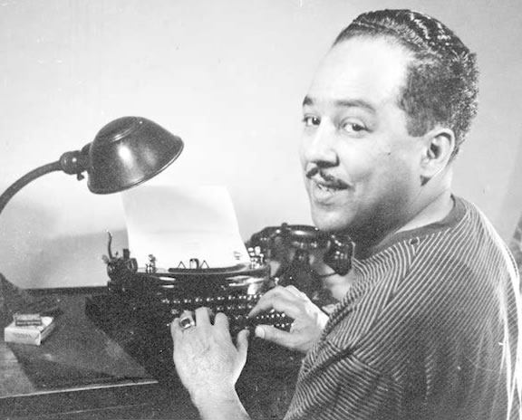
To You
By Langston Hughes

To sit and dream, to sit and read,
To sit and learn about the world
Outside our world of here and now —
Our problem world —
To dream of vast horizons of the soul
Through dreams made whole,
Unfettered, free — help me!
All you who are dreamers too,
Help me to make our world anew.
I reach out my dreams to you.

Analysis of the Poem –
Lines 1 – 2: The speaker wishes “to sit and dream, to sit and read, to sit and learn about the world.” How is it possible to make the world better by reading and dreaming? (10 pts)

____________________________________________________________________________________________________________________________________________________________________________________________________________________________________________________________________________________________________________________

Lines 3 – 4: The speaker wishes to exist “outside our world of here and now – our problem world.” Based on your knowledge of Langston Hughes’ life and experiences, describe his “problem world.” What were some of the things he wanted to change? (10 pts)

_________________________________________________________________________________________________________________________________________________________________________________________________________________________________________________________________________________________________________________________________________________________________________________________________

Lines 7- 10: Notice the structure in “Unfettered free – help me!” This phrase continues to
Line 8, but the “help me!” is powerful here, as if it is alone. The phrase is part of a request, “—help me! All you who are dreamers, too, help me to make the world anew.” Read the poem aloud now, and use the phrase in both ways, as an isolated urgent call, and as part of a larger request.

Notice Word Choice – Read the lines below and think about the choice of the word “unfettered.” “Unfettered” means “unchained, unlimited, unrestricted.” What images or other words come to mind with the use of the word “unfettered.” (10 pts)

To dream of vast horizons of the soul
Through dreams made whole,
Unfettered, free —

Words and images related to the use of the word “unfettered” or unchained:

Connect to the Literature:

If you were to make the world a better place, what would be the first three things you would do? (20 pts)
_______________________________________________________________________________________________________________________________________________________________________________________________________________________________________________________________________________________________________________________________________________

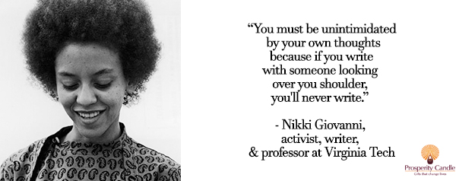

“The World Is Not A Pleasant Place To Be” by Nikki Giovanni

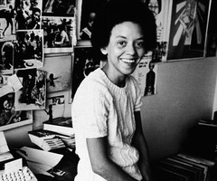
The World Is Not A Pleasant Place To Be
by Nikki Giovanni
the world is not a pleasant place
to be without
someone to hold and be held by
a river would stop
its flow if only
a stream were there
to receive it
an ocean would never laugh
if clouds weren't there
to kiss her tears
the world is not
a pleasant place to be without
someone

Analysis of the poem –
- What makes the world more pleasant, as shown in the 1st stanza? (10 pts)
______________________________________________________________________________________________________________________________________________________________________________________________________________________________________________________________________________
- The speaker uses the metaphor of a river to describe something greater. What the author saying in the 2nd stanza? (10 pts)
______________________________________________________________________________________________________________________________________________________________________________________________________________________________________________________________________________

- What do we all need sometimes to be happy, as shown in the 3rd stanza? (5 pts)

_______________________________________________________________________________________________________________________________________________________________________________________________________________________________________________________________________________________________________________________________________________________________________
- Notice the repetition used in the 4th stanza. What simple message is the speaker giving? (5 pts)
____________________________________________________________________________________________________________________________________________________________________________________
_____________________________________________________________________________

Text-Self/Text-World Connections —
According to the messages in this poem, what can we all do to make the world a more pleasant place to be for ourselves and for others? The main ideas are included in each section. Add details and give examples from your life, your experiences, or from your knowledge of the world. (20 pts)

What Makes the World a Better Place?
To hold and be held: We Should . . .

To give: We Should . . .

To be supported: We Should . . .

www.elahelp.com egennosa@sachem.edu

