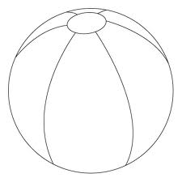
Katie Gennosa English
9/9/12 Mrs. McCann

I AM

I am a funny girl who loves the beach.
I wonder what I will become in 10 years.
I hear people struggling for help.
I see great opportunities opening up everywhere.
I want people to see how they treat each other.
I am a funny girl who loves to beach.

I pretend to be a marine biologist.
I feel sometimes the whole world is against me.
I touch the hearts of others.
I worry when I have done something wrong.
I cry when my friends or family are hurt.
I am a funny girl who loves the beach.

I understand that everyone’s not perfect.
I say to never give up.
I dream of being a star.
I try to make good choices and good friends.
I hope people will start caring more about
the planet they live on.
I am a funny girl who likes the beach.

